**CASE STUDY OF SASOL LIMITED**

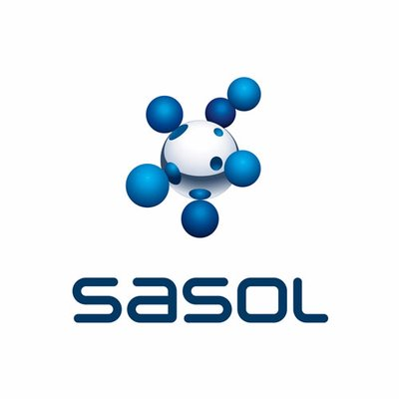

Project Phase 1 -

Database Initial Study

**Group Members:**

[32969694 - L Anthony] – (Group Leader)

[30010993 - MC Steyn]

[28612337 - CL Isaacs]

[31614132 - Z Stoltz]

[31775357 - S Boshoff]

[33648263 - L Steyn]

[32752008 - B Ngubane]

[25909932 - N van der Linde]

CMPG 311

Lecturer: Mr. H. van Rensburg

Submission date: 26 March 2021

**Table of Contents**

**Background study** 1

**Analyse company situation**1

Company operations 1

Company objectives 3

Company organizational structure 3

**Define problems and constraints**7

Company problems 7

Company constraints 7

**Database system specification**8

Objectives to solve identified problems 8

Information the company requires from the database 8

Scope 9

Boundaries 9

Conclusion 10

**Reference List**11

Project Phase 1 – Database Initial Study

## Background study

Sasol is a South African based energy and integrated chemicals company that has extended its trade and production to a global level. Currently, Sasol has active business dealings in more than 30 countries (Sasol, 2021; Sasol Limited, 2021a). The company’s main operations revolve around the mining of raw materials to produce gas and liquid fuel, as well as evolving chemicals to meet consumer needs. Over the years Sasol has made a deliberate and conscientious move to be more sustainable in its production of energy and integrated chemicals. (Sasol, 2021)

2020 has proven to be an exceptionally challenging year all over the globe and as such has left its mark on Sasol as well. The challenges that had arisen due to the Covid-19 restrictions placed on the workplace and society had led to its own challenges. These challenges forced Sasol to revise its current business strategies and devise a new long-term plan to support their ongoing sustainability efforts. (Sasol, 2021)

Sasol has approached our team to design and implement a database system that manages the amount of coal mined at each mining site, the amount of coal that is globally and locally exported, an employees monitoring system and a way to monitor the cost of production more efficiently.

# Analyse company situation

## Company operations

Sasol contains two different market-focused businesses, namely: chemicals and energy. Over the years Sasol has made the necessary changes to deliver sustainable value to its core business functions. (Sasol, 2021)

Sasol’s chemicals business function grows by meeting specified consumer needs. This business consists of base chemicals and performance chemicals, which involves Sasol having a broad range of integrated alcohols and surfactants. (Sasol, 2021)

Sasol’s energy business function, on the other hand, reacts to global trends. Currently, Sasol has six coal mining operations in South Africa. The coal procured from these mines are used as a raw material at the Sasol complexes in Secunda and Sasolburg. Sasol has developed an action plan to decrease the company’s greenhouse gas emissions. This was done to ensure that coal will be sourced sustainably and delivered to the Secunda and Sasolburg complexes at the lowest cost possible (Sasol Limited, 2020:98). The Secunda complex primarily uses coal as a raw material for gasification, but a limited amount of the coal is also used for the generation of electricity. The Sasolburg’s complex uses the supplied coal to produce electricity and steam. These complexes provide solutions to the following: (Sasol, 2021)

* new energy;
* the reduction of greenhouse gas emissions;
* to grow the gas and renewable energy sector in Southern-Africa; and
* to increase revenue.

Sasol has refocused its values to stay connected with customers. These refocussed values aim to orientate daily interactions and behaviours to be more action-oriented. These reinforced values are: (Sasol, 2021)

* Be safe - this is a priority and as such it forms an important part of day-to-day operations. Every employee must return home safely.
* Be caring - without care, Sasol cannot decarbonise the planet or ensure the safety of its employees. This is important because it encompasses a few things like employee focus, empowerment, and engagement.
* Be inclusive - include everyone - be it stakeholders, customers, or employees.
* Be accountable - produce results due to hard and honest work.
* Be resilient - be able to adapt to change and embrace agility. Since Covid-19, Sasol’s employees have shown remarkable innovation and agility. This was achieved through them dealing with:
  + reduced product demands and price;
  + smarter operation of plants;
  + alternatives to save money and make the company’s portfolio more attractive to investors;
  + negotiating contracts with suppliers; and
  + delivering results at legal and banking discussions.

## Company objectives

As a company, Sasol's main objective is to continuously innovate to create a better world. Sasol has adopted this objective to promote its belief that anything is achievable throughout the company. With this objective, Sasol strives to continuously improve and evolve their products and technologies in new and exciting ways. Sasol views innovation as an integral part of the company and its future. (Sasol, 2021)

Sasol has identified 3 main secondary objectives within this main objective, namely: (Sasol, 2021)

* People – Sasol aims to improve its employee’s perceived value through training, contributing to the community through community projects, as well as to establish and enhance stakeholder and customer relations.
* Planet – as part of Sasol’s initiative to improve the sustainability and environmental friendliness of its products, it has established 4 Sustainable Development Goals. These goals aim to: (Sasol, 2021)
  + Promote reasonable work and economic growth;
  + Promote the responsible use and manufacturing of products;
  + Improve the company’s environmental footprint and to act on climate change; and
  + Enter partnerships that will help the company to achieve its goals.
* Profit – Sasol will become a more attractive investment opportunity if the other secondary objectives are achieved.

## Company organizational structure

The effective leadership of Sasol Limited consists of the following: (Sasol Limited, 2021b: 2)

* Board of Directors
* Audit Committee
* Remuneration Committee
* Risk and Safety, Health and Environment (SHE) Committee
* Nomination, Governance, Social and Ethics Committee
* Capital Investment Committee

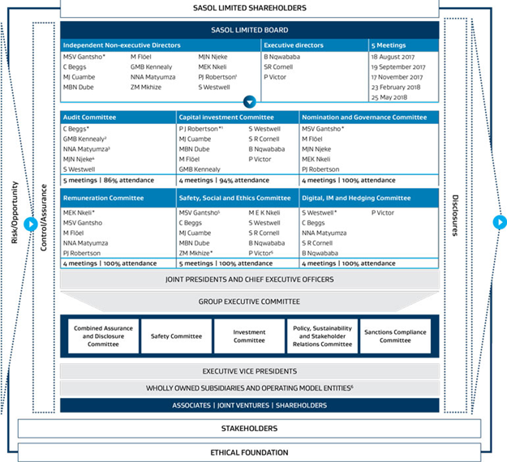*(Sasol, 2021)*

The Board of Directors add significant value to the company. The Board determines the demarcation of roles, functions, responsibilities and powers of the directors, executives and other officials. (Sasol Limited, 2021b: 1)

The Audit Committee reviews the audit plans of the company. This committee also reviews matters that have to do with accounting, auditing, financial reporting along with corporate governance and compliance thereof. (Sasol Limited, 2021b: 3)

The Remuneration Committee is responsible for creating a performance-driven environment. They must ensure that remuneration is competitive, sustainable, and globally applicable. (Sasol Limited, 2021b: 3)

The Risk and SHE Committee reviews and assesses the integrity of the risk management processes. These committees also assess the risks posed to safety, health, environmental and sustainability implementations. It is also the committees’ responsibility to ensure that risk management processes comply with the relevant requirements and that all of these processes are successfully implemented. (Sasol Limited, 2021b: 3)

The Nomination, Governance, Social and Ethics Committee review and make recommendations of the following: (Sasol Limited, 2021b: 4)

* Legal compliance and the company’s ethics policy;
* Appointment or reappointment of directors, taking into consideration their independence;
* Ensuring that the company’s corporate governance framework is appropriate and effective; and
* Ensuring continuous professional development of the Board, Committees, and employees.

The Capital Investment Committee evaluates capital and other investments, mergers, acquisitions along with proposed joint ventures. The committee also monitors approved capital projects and other investments. (Sasol Limited, 2021b: 4)

One of Sasol Limited’s many subsidiaries is Sasol Mining. Sasol Mining consists of 6 local coal mines (Sasol, 2021). DuPont Sustainable Solutions forms part of this subsidiary. DuPont’s role in the mines is to assist with the implementation of a safety coaching programme. DuPont also supports the mines’ operational teams in fostering risk reduction and continuous improvement (Sasol Limited, 2020:98). A generalised organisational structure for these mines follow.

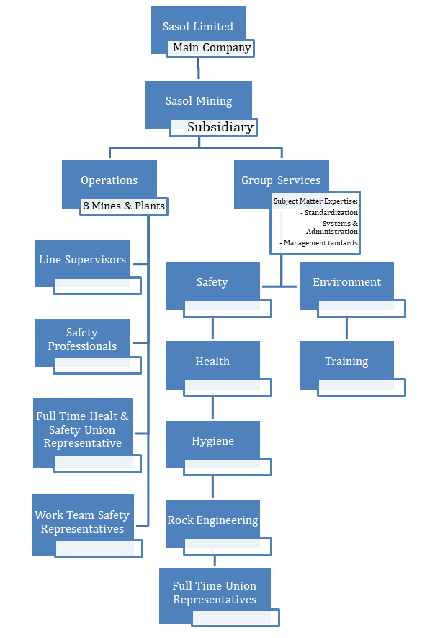

*Mining Organizational Structure (Sutedja, 2005: 2)*

# Define problems and constraints

## Company problems

Sasol’s current system is outdated and no longer supports an efficient and constructive work environment. Sasol has approached our company to help improve the current system by addressing the following problems:

* System glitches - the system was engineered for onsite employee input, but had to be used as an offsite system over the last year due to Covid-19 restrictions.
* Employee working hours - Covid-19 restriction has forced most of the administrative employees to work from home. This resulted in Sasol being unable to monitor some of the workforce’s hours.
* Employee health - employee health needs to be constantly monitored in light of Covid-19.
* Employee training - Covid-19 has brought employee training and development to a halt.
* Human error - sometimes end-users enter the incorrect data into the system.
* Covid-19 lockdown restrictions - Covid-19 is an ongoing crisis that the world and South Africa needs to face. Given this crisis, Sasol needs to constantly review current lockdown restrictions to ensure that they are complying.

## Company constraints

* Covid-19 restrictions - only a limited number of employees are allowed to work at the same time due to Covid-19 restrictions.
* Areas in which different employees work need to be monitored.
* Only 50 employees are allowed to work at any given facility.
* Employees are only allowed to work a maximum of 13 hours overtime.
* Employees’ ever changing roles and responsibilities need to be clarified.
* Employee records, training and loyalty need to be taken into account when determining wages.

# Database system specification

## Objectives to solve identified problems

* Virtual logins will need to be implemented, thus the system will need to be monitored to ensure effective and efficient access to the system.
* Administrative employees will rotate their onsite office-hours, the amount of employees will still comply with the Covid-19 restrictions. These employees will then be responsible for monitoring their own working hours.
* Employees will have to complete a daily survey to ensure that they are not showing any symptoms related to Covid-19. If they do not comply with this, they will not be able to enter the premises.
* Scheduled employee training will be done using platforms such as MIcrosoft Teams or Zoom. In case of practical training sessions, employees will receive scheduled and monitored training in small groups.
* Users will be adequately trained in data validation techniques before entering data to ensure that the data is entered correctly.
* Weekly briefings will be scheduled in order to ensure that the company complies with the current lockdown restrictions.
* The new database should respond to queries in a timely manner. (Ad hoc queries and responses)
* The new database must be created in the 3rd normalization phase to avoid data redundancy and data anomalies.

## Information the company requires from the database

Sasol requires the database to retain the following data:

* Complete and accurate employee information – this includes status (current or past employee), name, surname, trade code (demolitions expert, etc.), department code (safety, line supervisor, etc.), contact information, shift number.
* Complete record of employee’s employment history – a record of all disciplinary actions, commendations, overtime, leave, promotions, demotions, raises, etc.
* Employee schedules and workplace – all the different shift hours of the mine, indication of the shift each employee is currently on, lockdown restriction level and employees allowed to work onsite per shift, number of employees working onsite and offsite per shift.
* Monitoring of hours – a system to keep track and record the number of hours that employees have worked onsite and offsite.
* Amount of coal mined per day – a monitoring system that keeps track of the amount of coal mined per day measured in tons.
* Coal in storage – a monitoring system that keeps track of the amount of coal that is currently in storage (measured in tons) and the assigned destination of the coal.
* Transportation of coal – needs to keep track of the destination of each truck, amount of coal loaded onto each truck (measured in tons), and the trucks status (loading, in transport, unloading).

## Scope

* Maintain employees
* Maintain employee salaries
* Maintain employee training
* Maintain coal mining
* Maintain coal exports
* Maintain environmental projects
* Funding of environmental protection projects
* Monitoring the lockdown levels
* Apply applicable lockdown restrictions

## Boundaries

The following boundaries have been imposed by Sasol and the current (and constantly changing) Covid-19 lockdown restrictions:

* Sasol provided a budget of R200 000 to complete the project, it may thus not be possible to incorporate all of the desired solutions into the new database system.
* There are currently 8 employees who are available to work on this project. This may speed up the system development process, but it will cost more.
* The system should be developed and deployed within a duration of three to four months.
* Employees who are going to use this system must be trained, which might extend the time it will take to fully implement the new system.
* Preferred operating System to implement the database is Windows 10, with either SQL Server or Oracle as the DBMS.
* Hardware: at least 8GB of RAM.

## Conclusion

The analysis above leads to the conclusion that an updated database system is of the utmost importance for Sasol to continue with its daily functions. Sasol will definitely benefit from this database system, because maintaining employee activities will become much easier and therefore it requires less time, along with the effort required to manage such operations.

# Reference List

Sasol Limited. 2020. *Integrated Report 2020.* <https://www.sasol.com/sites/default/files/financial_reports/Integrated%20Report%202020.pdf> Date of access: 24 March 2021.

Sasol Limited. 2021a. *Sasol Society.*<https://society.sasol.com/about-us/>Date of access: 23 March 2021.

Sasol Limited. 2021b. *Effective leadership and corporate citizenship.* <https://www.sec.gov/Archives/edgar/data/314590/000104746915007768/a2225938zex-99_2.htm> Date of access: 23 March 2021.

Sasol. 2021. *Overview.* <https://www.sasol.com/about-sasol/company-profile/overview> Date of access: 23 March 2021.

Sutedja, S. 2005. *Sasol Mining: Contractor Management 16 Feb 2005.* <https://slideplayer.com/slide/14988790/>Date of access: 24 March 2021.